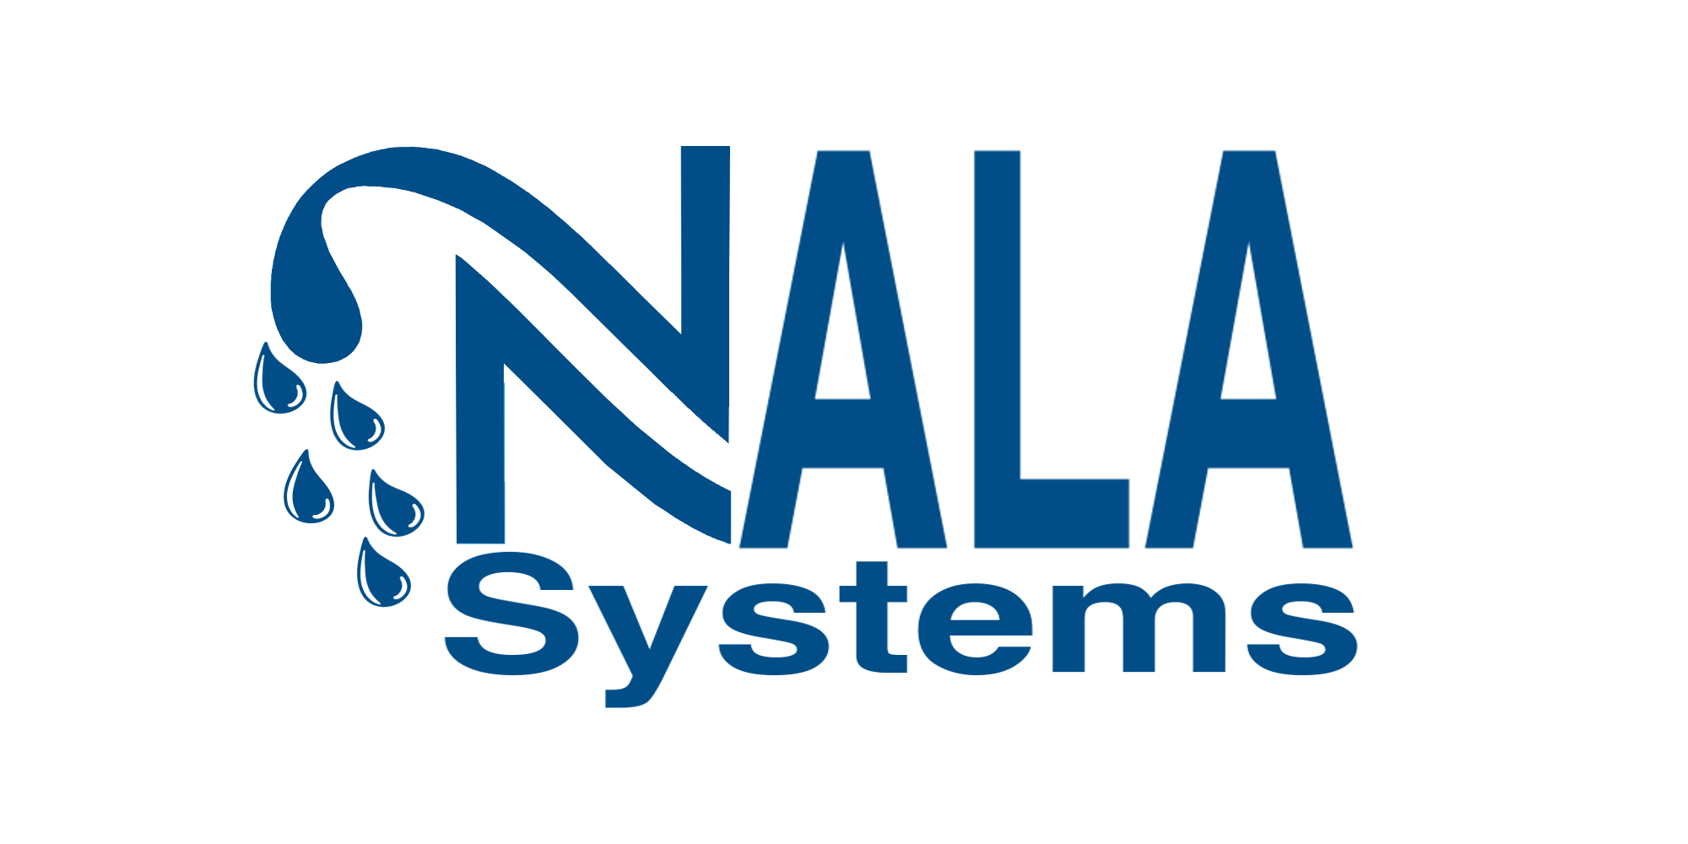

NALA SYSTEMS Wins Industry Driven - Cleantech Award at 2021 NC Tech Awards

Raleigh, N.C. (Nov. 10, 2021) – NALA Systems is proud to announce it has been selected as the 2021 winner of the “Industry Driven - Cleantech Award” at the NC TECH Awards. Winners were recognized at the NC TECH Awards Gala on Wednesday, November 3, presented in conjunction with title sponsor Cherry Bekaert.

The NC TECH Awards is North Carolina's only statewide technology awards program, recognizing companies and individuals who have demonstrated growth, innovation, and leadership. For more information on the selection process, categories, finalists, winners, and the awards gala, visit www.nctech.org/awards.

“We are honored to be selected for the NC Tech Cleantech Award. Our mission to bring new membranes to market and reduce the cost and complexity of water purification is empowering and has world impacting implications, “ said Sue Mecham, CEO.

“This award validates our mission and progress, and we are excited to bring water to the front of cleantech conversations in NC. This award is good timing to highlight our accomplishments as we are planning to raise additional capital and hire more staff in the coming year,” continued Mecham, who together with her mother Dr. Judy Riffle have pioneered a new class of innovative materials designed to overcome long-standing limitations from existing membranes.

Current clean water reverse osmosis systems use membranes that require high amounts of energy and are also prone to biofouling – both difficult problems that NALA has solved with its non-polyamide membranes that are being tested with U.S. and global hydrohubs

“Since 1995, the NC Tech Awards has honored excellence and innovation throughout North Carolina, representing the best and brightest,” said Brooks Raiford, president and CEO of NC TECH. “As a winner, NALA Systems has distinguished itself as a peer-leader and we are proud to recognize them as a 2021 NC Tech Awards winner.”

About NC TECH: NC TECH is a not-for-profit, membership-driven trade association and the primary voice of the technology industry in North Carolina. NC TECH’s mission is to foster growth and champion innovation in North Carolina’s tech sector, while providing a voice for the tech community. NC TECH’s membership includes close to 600 member companies, organizations and institutions employing more than 200,000 workers in North Carolina. For more information, visit nctech.org.

About NALA Systems: NALA Systems, founded in 2018 by a mother-daughter duo, is a women led cleantech startup company located in Research Triangle Park, NC. The NALA team of chemists and engineers is developing chemically resistant polymer membranes that make desalination and water purification, using reverse osmosis, easier and more affordable. NALA is paving the way for innovation in the water industry with their new material membranes that are chlorine tolerant and low fouling. By reducing energy and chemical cleaning and disposal, NALA’s new membranes will drive down the cost of membrane separations to increase sustainability in industrial and municipal water treatment and separations. NALA has been funded through the National Science Foundation (NSF) SBIR program (phase I and phase II) and by venture capital and angel investors to rapidly develop and commercialize their membrane innovation. NALA subscribes to ESG principles in it’s research, investment and operations.

For more information about the NC Tech Association visit www.nctech.org. For more information about NALA Systems please visit www.nalasystems.com or email Sue Mecham at sjmecham@nalasystems.com.

